NOTICE TO RESIDENTS

OUTDOOR MOVIE NIGHT at RAY PERRAULT PARK
Amplified Sound

On Friday September 1 2023, the City of North Vancouver is hosting the LAST of the popular FREE movie nights – and this is the first one we are bringing to Ray Perrault Park.

As this is a public event, you are welcome to attend!! If you choose to do so, you may want to bring a blanket, pillow, or small chair to sit on for your comfort. Washrooms will be available by the Playground.

Fresh Air Cinemas will be screening the 2016 Disney computer animated buddy cop comedy Film Zootopia.
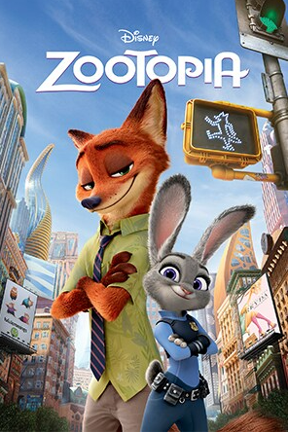

Location: Near the Playground, the screen will be opposite 1400 block Moody
Date/Time: Friday, September 1 at 8:10 pm (sunset) until approx 10:30 pm
Movie: Zootopia (2016), Rated PG

The sound from the speaker system may be audible in residences surrounding the Park, and because of this, we apologize for any inconvenience this event may cause you. (Also the sounds of the screen being taken down may continue past 11pm).

As these outdoor events are weather dependant, if the forecast is for rain or smoke this movie night will be postponed to a later date.

If you have any questions regarding this event, please contact Clare at events@cnv.org or 604-982-3910.

NOTE: This is event weather dependant. If cancelled the news will be on the City’s Facebook (https://www.facebook.com/CityOfNorthVancouver) or Instagram page (https://www.instagram.com/CityOfNorthVancouver/)

