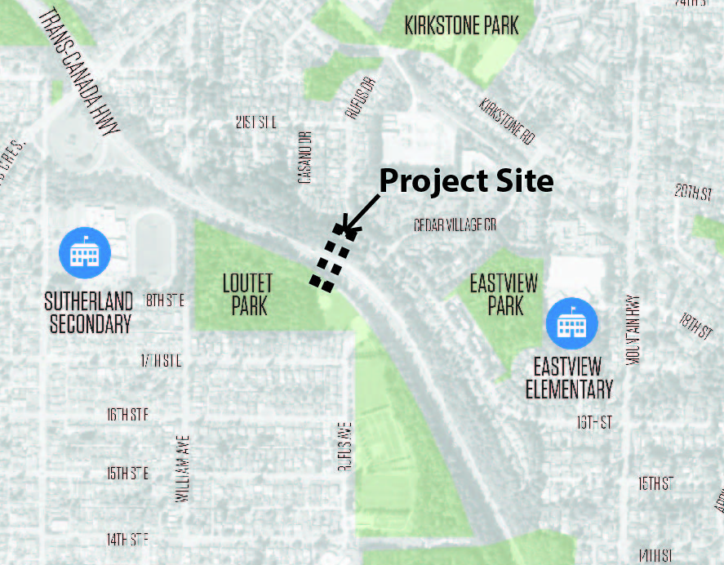


OPEN HOUSE #1
Loutet Casano

Pedestrian Cycling Overpass

The City of North Vancouver is developing a conceptual design for a new cycling and pedestrian overpass over Highway #1, and we are holding an Open House on March 2nd from 5:00pm to 7:30pm to hear your thoughts on the project.

This initiative recognizes Highway #1 as a barrier for pedestrians and cyclists, and supports the City’s Long Term Transportation Plan by linking the Loutet and Cedar Village neighbourhoods. City Staff will be present to discuss the initial concept ideas and background work for the project.

For more information, please visit our website at www.cnv.org/LoutetOverpass

What:
Public Open House for the Loutet Casano Pedestrian Cycling Overpass

Where:
Sutherland Secondary School, 1860 Sutherland Ave.,
North Vancouver

When:
Thursday, March 2nd
from 5:00 pm – 7:30 pm

For more information:
www.cnv.org/LoutetOverpass

Or contact:

Adam Vasilevich
Parks and Greenways Planner
City of North Vancouver
Engineering, Parks +
Environment

Jessica Oakes
Landscape Design Technician
City of North Vancouver
Engineering, Parks +
Environment

Tel: 604-983-7333
Email: eng@cnv.org

We look forward to hearing
your feedback!

City of North Vancouver
141 West 14th Street, North Vancouver, BC V7M 1H9
Phone: 604.985.7761 | Email: info@cnv.org | www.cnv.org

